**Software Development Plan Template**

**TITLE PAGE CONTENT**

**Mentcare**

**12/3/2023**

1.0

**Presented To:**

Dr. Mohamed Ramadan

**Submitted By:**

EL G.O.A.T

**REVISION HISTORY**

| **Date** | **Author** | **Distributed to** | **Version** | **Description** |
| --- | --- | --- | --- | --- |
| 12/3/2023 | ALL | Dr. Mohamed Ramadan | 1.0 | First fill out the form |

**1. PRODUCT DESCRIPTION**

**1.1 Product Perspective**

**Mentcare System is a new stand-alone product to help hospitals and health clinics that treat mental illnesses do their work, where each user has his own user interface to help him do his own work, in addition to that the system provides patients and medical staff with services in a quick, easy and more efficient manner, the most important of which is follow-up and monitoring of the patient's condition And predict the presence of any errors or dangerous condition.**

**1.2 Product Functions**

* **Monitor patient appointments.**
* **Monitor the patient's condition and help treat his condition.**
* **Predicting the future of a dangerous condition.**
* **Warning when there is a dangerous condition.**
* **Classification of patients as dangerous or normal.**
* **Create reports.**
* **Pay and calculate costs.**
* **Modify, add or delete data of all kinds**

**1.3 User Classes and Characteristics**

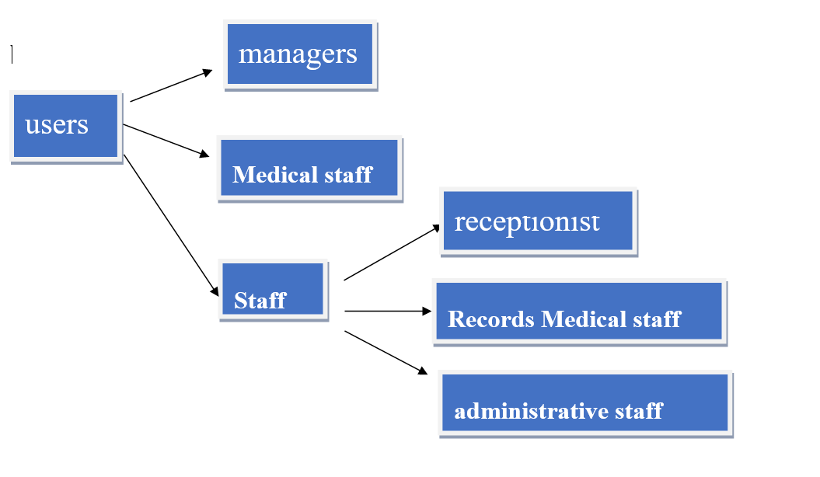**Users of the system include clinical staff such as doctors, nurses, and health visitors (nurses who visit people at home to check on their treatment). Nonmedical users include receptionists who make appointments, medical records staff who maintain the records system, and administrative staff who generate reports,and Manager .Given the condition that not all the users are computer-literate. Some users may have to be trained on using the system..**

**2. TEAM DESCRIPTION**

**Our team is responsible for developing and implementing the Mentcare System, a comprehensive healthcare management platform. The team consists of six members with diverse backgrounds and skill sets.**

**1-Technical expertise: The team members have a strong technical background in software development, programming languages, database management, and other relevant technologies.**

**2 - Communication skills: The team members communicate clearly and concisely with each other and with stakeholders.**

**3- Problem-solving skills: Software development involves solving complex problems. The team members analyze problems and come up with innovative solutions.**

**4- Attention to detail: Software development requires a high level of attention to detail.**

**5- Time management skills: The team members manage their time effectively and prioritize tasks accordingly.**

**6 -Teamwork: The team members should be able to work together effectively and support each other throughout the project.**

**7- Adaptability: Software projects can be unpredictable, and requirements may change over time.**

**Overall, having a diverse set of skills among the team members can help ensure a successful software project delivery within budgeted timeframes while meeting quality standards expected by stakeholders or end-users like Mentcare Health users or patients who will use this system for their health care needs**

**there is a need for a Subject Matter Expert (SME) who has expertise in the healthcare industry and can provide insights into the specific needs of the mentcare system. This person can help ensure that the system meets the requirements of healthcare professionals and patients.**

|  |  |
| --- | --- |
| **Name** | **Skills** |
| **Sarah Kamel** | **Full Stack Web Developer** |
| **Shaima Ahmed** | **Full Stack Web Developer** |
| **Esraa Mohammed Abu Al-Wafa** | **Back End developer** |
| **Ibtihal Abdel Moneim** | **Back End developer** |
| **Fatima Abdel Samad** | **Back End developer** |
| **Roar Abdel Nasser** | **Back End developer** |

**3. SOFTWARE PROCESS MODEL DESCRIPTION**

**In our software, we chose agile model. Why Agile? Because our project is operating in an ever-changing environment, it is impossible to gather a complete and exhaustive set of software requirements. Without these requirements, it becomes practically hard for any conventional software model to work. Agile has a lot of Principles:**

**1. Highest priority is to satisfy the customer through early and continuous delivery of valuable software.**

**2. It welcomes changing requirements, even late in development.**

**3. Deliver working software frequently, from a couple of weeks to a couple of months, with a preference to the shortest timescale.**

**4. Build projects around motivated individuals. Give them the environment and the support they need, and trust them to get the job done.**

**5. Working software is the primary measure of progress.**

**6. Simplicity the art of maximizing the amount of work not done is essential.**

**7. The most efficient and effective method of conveying information to and within a development team is face-to-face conversation.**

**The Agile is also support Pair Programming. In Pair programming, two programmers work together at one workstation. One does coding while the other reviews the code as it is typed in. The two programmers switch their roles every hour or so.**

**4. PRODUCT DEFINITION**

**Context Diagram**

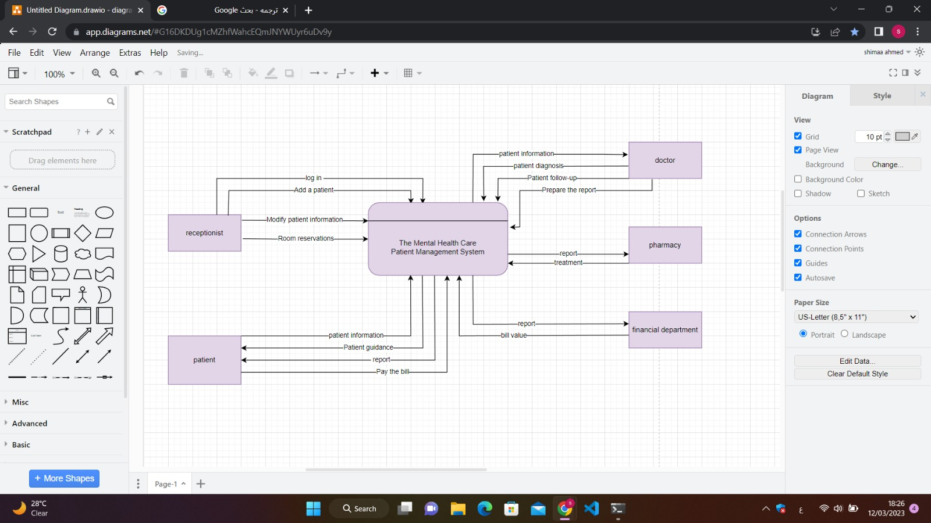

**Personas**

**It was mentioned above,and**

Brief description of people outside the mental healthcare system that the system interfaces with:

**Family and Friends**:

Family and friends of patients are an important part of the mental healthcare system as they provide emotional and practical support to the patient throughout their treatment journey. They can also act as advocates for the patient, communicate with healthcare professionals, and help to facilitate the patient's recovery and reintegration into their community.

**Referring Providers**:

Referring providers, such as primary care physicians or therapists, can refer patients to mental healthcare services and play a crucial role in identifying and addressing mental health concerns. They may also collaborate with mental healthcare professionals to provide integrated and coordinated care for the patient.

**Insurance Providers:**

Insurance providers are a key external stakeholder in the mental healthcare system as they can provide coverage and financial support for mental healthcare services. They may also set policies and guidelines for mental healthcare coverage, influence reimbursement rates, and play a role in determining the availability and accessibility of mental healthcare services.

**Community Organizations:**

Community organizations, such as non-profit groups or faith-based organizations, can play a supportive role in the mental healthcare system by providing resources, education, and advocacy for mental health issues. They may also collaborate with mental healthcare providers to offer services or programs that address the unique needs of specific populations or communities.

**User Stories**

**As a patient in a mental hospital,**

**I want to feel safe, supported, and comfortable during my stay,**

**so that I can focus on my recovery and healing.**

**This includes having access to comfortable and clean accommodations, nutritious and balanced meals, and a variety of therapeutic and recreational activities to engage in. I also want to have access to qualified and compassionate mental health professionals who can provide me with individualized care and support throughout my stay, as well as effective treatment and medication options as needed.**

**As a mental health professional working in a mental hospital,**

**I want to be able to provide high-quality and effective care to my patients**

**so that I can help them achieve their treatment goals and improve their overall mental health and well-being.**

**This includes having access to the necessary resources and tools to support my patients' recovery, as well as collaborating with other mental health professionals and staff to ensure coordinated and comprehensive care. I also want to feel supported and valued in my role, with opportunities for professional development and growth**

**As a hospital administrator,**

**I want to ensure that the mental hospital provides safe, effective, and high-quality care to all patients, while also being financially sustainable and efficient.**

**This includes overseeing the operations of the hospital, such as managing staff, facilities, and resources, as well as implementing policies and procedures to ensure compliance with legal and ethical standards. I also want to be able to track and analyze patient outcomes and satisfaction, as well as financial and operational metrics, in order to continually improve the hospital's performance and impact.**

**High Level Use Cases**

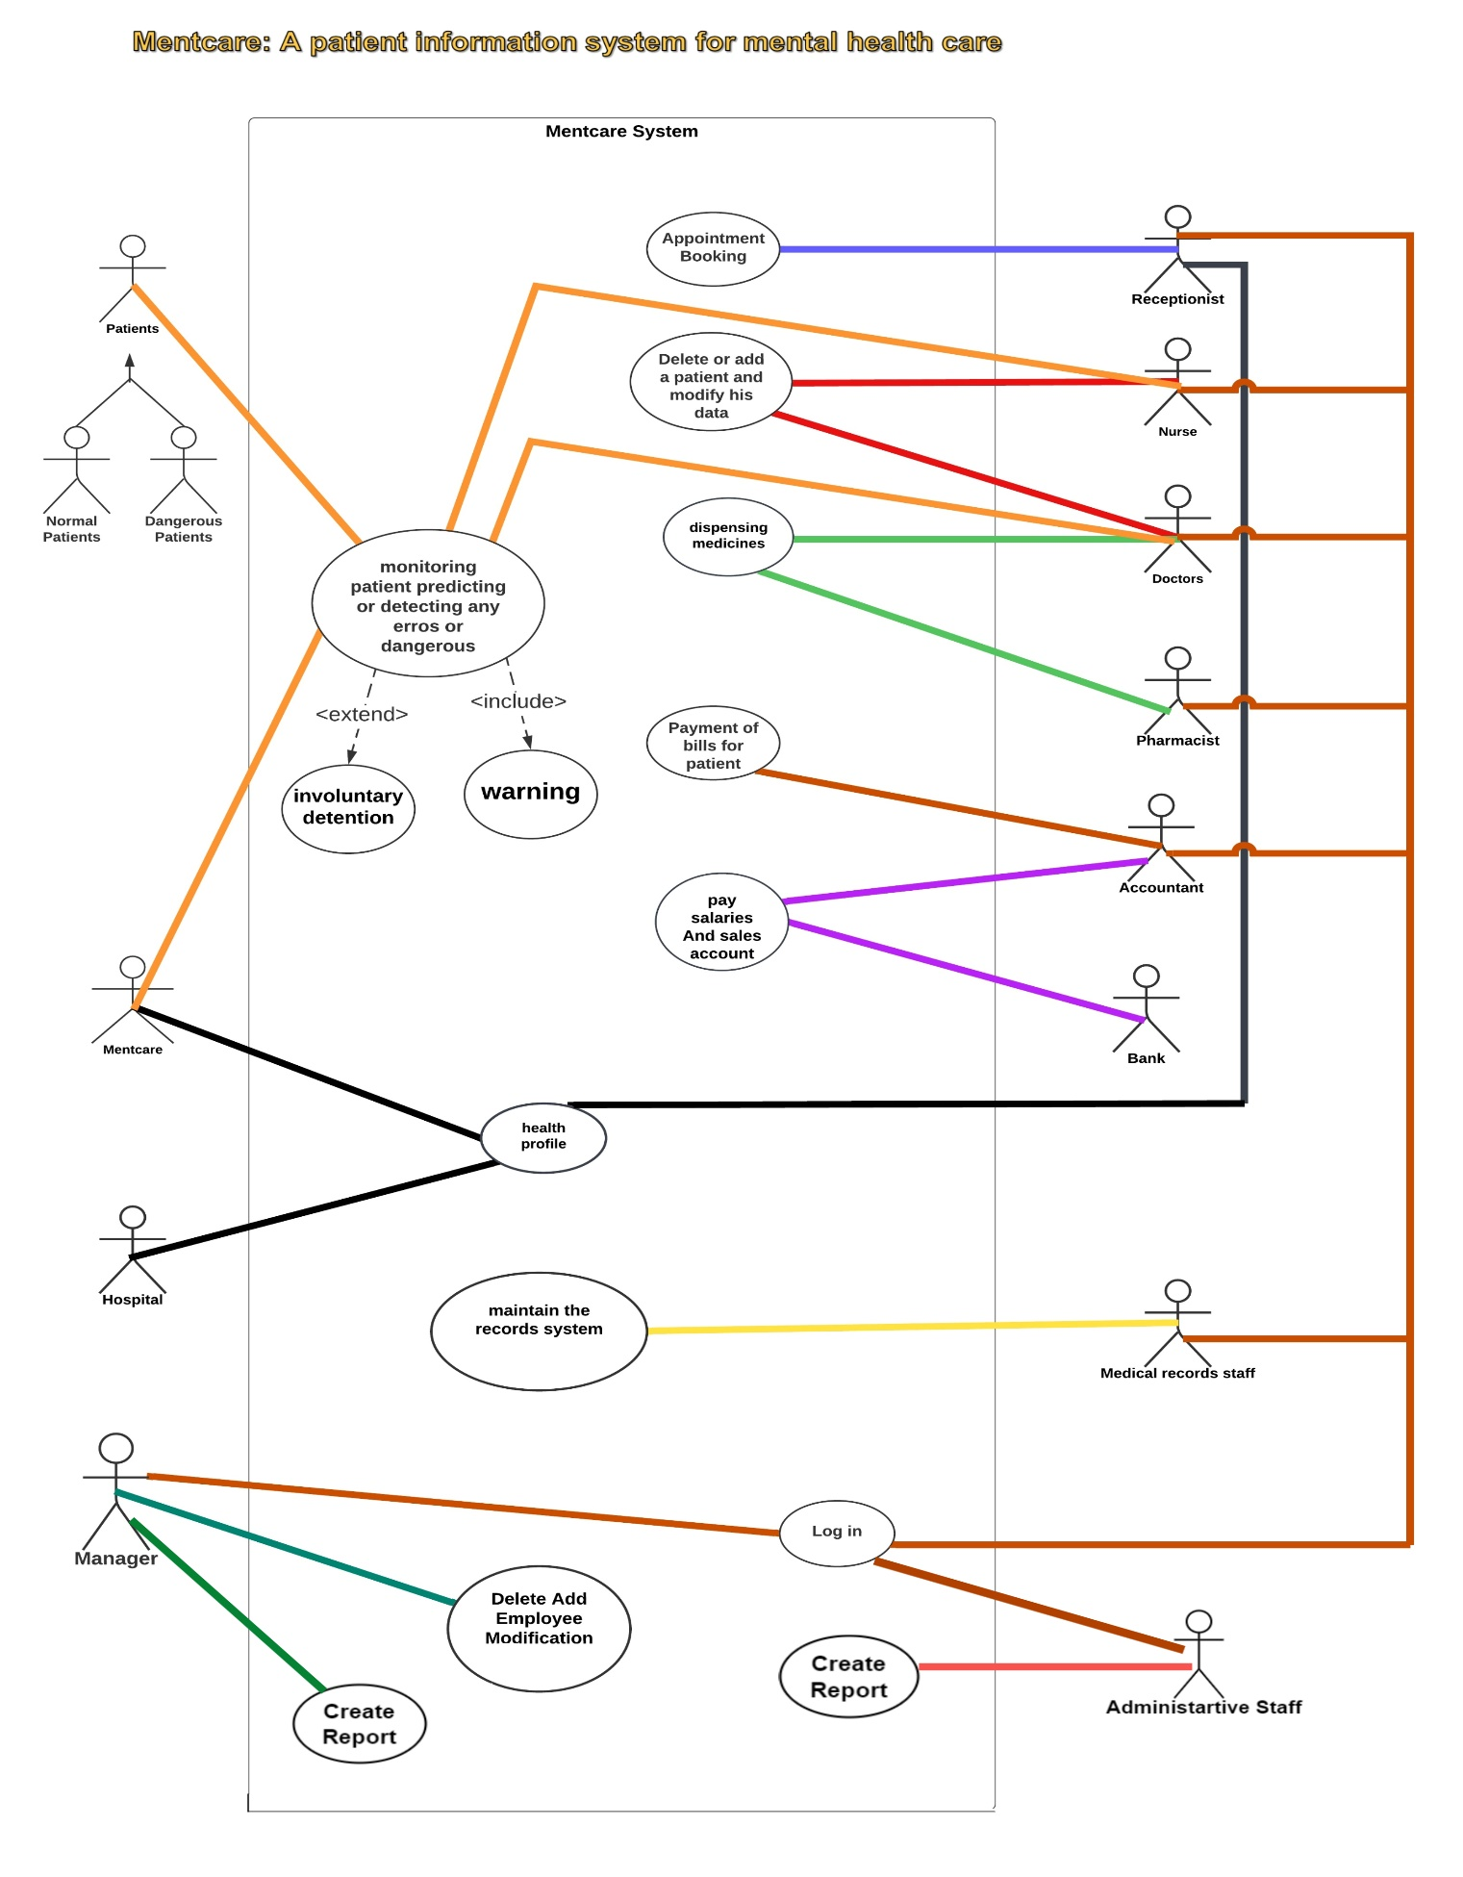

**Use Case Descriptions**

|  |  |
| --- | --- |
| **Use Case ID** | **1** |
| **Use Case Name** | **Appointment Booking** |
| **Description** | **Reserving an appointment for the patient for examination and diagnosis with the doctor through the reception** |
| **Participating actors** | **Receptionist, Patient or Relatives of the Patient** |
| **Precondition** | **1 - The patient must be registered in the system, and an appointment is available and suitable for the patient, for the success of the reservation process.** |
| **Trigger** | **For the patient or one of his relatives to go to the reception for reservation or to call the hospital for reservation.** |
| **Flow of events** | **1- The receptionist logs in to the system.**  **2- The patient or one of his relatives goes or calls to inquire about an appointment for the examination.**  **3- Using the system, the receptionist searches for the available and suitable appointments for the patient with the doctors in the hospital.**  **4- If a suitable date is found, the patient's data will be taken.**  **5- Register and confirm the reservation.**  **6- Follow up on the patient’s attendance.** |
| **Postcondition** | 1. **The patient is in the system and his reservation is confirmed.** 2. **Follow up the patient's attendance to his appointments and remind him of his appointment through the system and SMS messages.** |

|  |  |
| --- | --- |
| **Use Case ID** | **2** |
| **Use Case Name** | **Follow-up of the patient and alert the medical staff** |
| **Description** | **The doctor, nurse, and receptionist follow up on the patient’s condition, attend his appointments through the system, and warn the medical staff of any errors or predict the worsening of the patient’s condition.** |
| **Participating actors** | **Receptionist, Patient or Relatives of the Patient, Doctor, Nurse, and Receptionist** |
| **Precondition** | **1- The patient must be registered in the system and his health file is complete and available in the system.** |
| **Trigger** | **The receptionist records the patient's attendance and the doctor enters the progress of his treatment.** |
| **Flow of events** | **1- An SMS message is sent to the patient or his relatives to remind the patient of his reservation.**  **2- The patient's absence is recorded.**  **3- The patient and his relatives are warned not to attend the patient.**  **4- Recording the patient's failure to respond to the warning.**  **5- Warning the medical staff not to respond.**  **6- Confirmation of quarantine or its follow-up.** |
| **Postcondition** | **Following up the patient's condition in the required manner, recording and saving the progress of his treatment, predicting risks correctly, and reducing injuries.** |

**5. USER EXPERIENCE WIREFRAMES**

**The first page includes an introduction to our hospital, in addition to the services we provide, from which you can log in .**

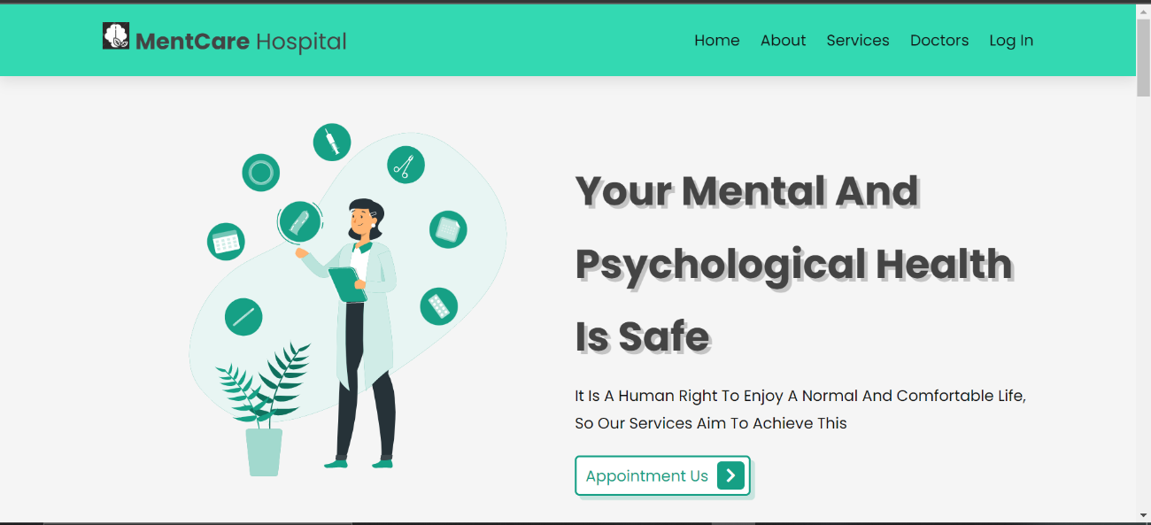

**Patient page:**

**Receptionist Page:**

**Doctor Page:**

**6. PROJECT ORGANIZATION**

|  |  |  |  |  |  |  |
| --- | --- | --- | --- | --- | --- | --- |
| Team Members  Concepts | Sarah Nabil | Esraa Abu Al-Wafa | Ibtihal Abdel Moneim | Fatima Abdel Samad | The roar of Abdel Nasser | Shimaa ahmed |
| interface design | x |  |  |  |  | X |
| Front-end by html | X |  |  |  |  | x |
| Front-end by css | X |  |  |  | x |  |
| Front-end by javescript | x |  |  |  | x | x |
| Database Management |  |  | X | x |  | X |
| Back-end |  | x |  |  | x |  |
| Website compilation |  | x | X |  |  |  |
| tset | X |  |  | X |  | X |
| User Management |  |  |  |  |  | X |
| Research | X |  | X | X |  | X |

## Matrix of Responsibilities

# 6. [PERT Chart](https://drive.google.com/open?id=1rj1XyvQ63gfzoeDCI-cp3nwjir7VcBzN)

**7. VALIDATION PLAN**

**Validation plan**

validation strategy:

A validation strategy typically includes the following steps:

1. Requirements Validation: The first step in a validation strategy is to ensure that the requirements and specifications set out in the design phase are accurate and complete. This involves reviewing and verifying the requirements with stakeholders to ensure that they reflect the needs of the hospital.
2. Design Validation: The next step is to validate the system design to ensure that it meets the requirements and specifications set out in the design phase. This involves reviewing and verifying the system design with stakeholders to ensure that it accurately reflects the needs of the hospital.
3. Development Validation: Once the system design is validated, the next step is to validate the development of the system. This involves testing the system to ensure that it meets the requirements and specifications set out in the design phase.
4. User Acceptance Testing: The final step in a validation strategy is to perform user acceptance testing. This involves testing the system with end-users to ensure that it meets their needs and is user-friendly.

**Test strategy:-**

Testing in a mental hospital requires a unique approach due to the highly sensitive and personal nature of mental health care. The following are some additional considerations to keep in mind when developing a test strategy for a mental hospital:

1. Patient confidentiality: Patient confidentiality is of utmost importance in mental health care. It is important to ensure that all testing efforts comply with relevant privacy regulations and that patient data is protected.
2. Patient safety: Patient safety is a top priority in mental health care. It is important to ensure that all systems and processes related to patient care are tested thoroughly to reduce the risk of harm to patients.
3. Usability: Usability is particularly important in mental health care. Patients with mental health conditions may have difficulty navigating complex systems or processes. It is important to ensure that all systems and processes related to patient care are user-friendly and easy to use.
4. Regulatory compliance: Mental hospitals are subject to strict regulatory and compliance requirements. It is important to ensure that all testing efforts comply with relevant regulations and that any compliance issues are identified and addressed.
5. Staff training: Staff training is critical to ensuring that all systems and processes related to patient care are used correctly. It is important to ensure that staff members are trained on all relevant systems and processes and that their training is regularly updated.

**Success criteria:-**

A hospital project is considered successful when it meets the expectations and requirements established at the start of the project. For example, stakeholders may consider a project successful if it’s completed on schedule and within budget. [Other factors that can contribute to the overall success of a project include organizational structure, culture and resources](https://www.hsph.harvard.edu/ecpe/a-primer-on-project-management-for-health-care/).The success of a test strategy in a mental hospital can be measured by the following factors:

1. Improved patient care: The ultimate goal of testing in a mental hospital is to ensure that patients receive high-quality care. A successful test strategy should result in improved patient outcomes, reduced medication errors, and enhanced patient satisfaction.
2. Improved efficiency: A successful test strategy should result in improved efficiency in hospital operations. This may include reduced wait times for patients, increased staff productivity, and streamlined processes.
3. Improved compliance: Mental hospitals are subject to strict regulatory and compliance requirements. A successful test strategy should ensure that the hospital is in compliance with all relevant regulations and that any compliance issues are identified and addressed.
4. Reduced risks: A successful test strategy should result in reduced risks to patients, staff, and the hospital. This may include identifying and addressing potential safety hazards, reducing the risk of medication errors, and improving the security of patient data.
5. Cost savings: A successful test strategy can result in cost savings for the hospital. This may include reducing the need for manual testing, improving staff productivity, and reducing the risk of costly errors or compliance violations.

The definition of done:

The definition of done for the validation plan of a hospital project is when all the specified functional and non-functional requirements have been met and the system has been thoroughly tested and validated to ensure that it meets the needs of the hospital and its patients.

Meeting the functional requirements means that the system performs the functions that it was designed to do, such as managing patient records, scheduling appointments, and processing billing. Meeting the non-functional requirements means that the system meets the performance, security, and scalability requirements that were set out in the design phase.

In addition to meeting the functional and non-functional requirements, the validation plan should also ensure that the system is compliant with all regulatory requirements, such as HIPAA regulations governing the handling of patient data.

Once all the requirements have been met, the system should be thoroughly tested to ensure that it is functioning correctly. This testing should include user acceptance testing to ensure that the system is user-friendly and meets the needs of healthcare professionals and patients.

Documentation is also an important part of the validation plan. All testing results should be recorded, and any issues or bugs that were identified during the validation process should be documented and addressed.

**8. FEASIBILITY STUDY**

**Risk Prioritization**

**1-The application is not noticed and no one would use it**

**2- Insecure data storage**

**3-Unreliable collection of record stores social media posts**

**Risk Mitigation:**

**Promoting and advertising the Record Store Application to show all the good features this app has, is a one way to get the other stores to use it for a small community then grows further to have more people use it. Security plays a big role in developing mobile applications. Data should always be stored within an encrypted data section and the app should be marked to disallow backup. Also, authorization of entered data from the other record stores is going to be considered to make sure we have a reliable data The should also be a reliable collection of record store information so that this app can become a central location for people searching for specific records. We must make sure that our web scraper is collecting all the information possible.**

**Risk Identification:**

**Our web scraping not effective enough to pick up on social media posts made by record stores- making the record app unreliable. A big factor in this app is it being able to be a central location for information; if we cannot supply that then it’s a risk.**

**9. CONFIGURATION AND VERSION CONTROL**

**We chose Git as our version control system due to its widespread adoption, distributed nature, and robust features for branching, merging, and tracking changes.**

**Our repository is structured as follows:**

**src directory: Contains the source code files for our website.**

**docs directory: Houses project documentation and user manuals.**

**config directory: Stores configuration files for various environments.**

**img directory: large image for project documents and screen-shot for front-End.**

**10. TOOLS**

**list of tools required for the mental health care project and their use :-**

**1-IDE (Integrated Development Environment):wu used an IDE such as Visual Studio Code, PyCharm, for writing,debugging, and testing the code for your mental health care project.**

**2-Version Control System (VCS): GitHub allow us to track changes, collaborate with others, and manage different versions of your project's source code.**

**3-Communication and Collaboration: Tools Microsoft Teams and Discord can facilitate communication and collaboration among team members ,They provide channels for real-time messaging, file sharing, video calls, and integration with other tools.**

**4-Database Management: we need a database management system such as MySQL These tools allow us to store and retrieve data efficiently and securely.**

**5-we have utilized the following programming languages and technologies for the backend and frontend development of the mental health care project:**

**Backend:**

**PHP: Used as the primary programming language for server-side development,handling logic and data processing.**

**MySQL: Employed as the relational database management system to store and manage the project's data efficiently.**

**Frontend:**

**HTML: Utilized for structuring and defining the content of web pages.**

**CSS: Implemented for styling and visually enhancing the HTML elements.**

**JavaScript: Employed for adding interactivity, handling events,**

**and performing client-side validations.**

**Bootstrap: Used as a responsive CSS framework to enhance the user interface and ensure consistency across different devices.**

**11. ARCHITECTURE**

**Building Hardware Architecture for Healthcare Network Computing for Internet of Things and Artificial Intelligence**

A healthcare IoT system includes four components edge device, gateway, workstation and mobile user interface. The components in the system are interconnected through wired or wireless network. An edge device contains at least a sensor to collect data from patient side and a processor to preprocess sensor data and delivers the preprocessed data to a gateway. The gateway is able to obtain or to integrate the received data from one or more edge devices in a secured or interoperable form and then conveys to a workstation. The workstation bears most data storage, analysis and visualization in a comprehensive or real-time perspective. The historical data or the retrospective data which needs huge data storage or computing resource is then transmitted to a cloud server. In addition, a mobile user interface may retrieve graphical information or data visualization from the workstation or the cloud server.

Usually, the architecture design can be aimed on low energy, high throughput, low latency or resource utilization. In low energy set, edge devices may be built with ARM core or Intel Atom processors on small form factor computer boards and the gateways may be built with laptop class processors and wireless LAN (WLAN). In high throughput set, edge devices may be built with faster processors and larger data storage buffer and the gateways may be built with Wi-Fi 802.11ac. For workstation, it can be built as a medical all-in-one (AIO) or a medical box pc with a powerful server level processor, such as Intel Xeon, is favored for data analysis and visualization.

Nowadays, the medical devices and health informatics are more interoperable from physical later to application layer. Data collected from sensors is preprocessed or filtered in a standard format. The system is capable to utilize gateways for data transmission with buffering or basic analytics. Also, most networking occurs among local area network (LAN) which increase cybersecurity and network reliability. The system reduces the burden of the cloud servers and reserves the key function of the cloud servers in high speed computing and data storage. Furthermore, healthcare professionals can retrieve visualized data more easily through the mobile user interface such as a medical tablet within LAN.